|  |  |
| --- | --- |
| Controller to Robot (message types):   1. Stop Command 2. Set Auto Mode – Alternating Pattern 3. Set Auto Mode – Square Pattern 4. Set Auto Mode – Star Pattern 5. Set Manual Mode 6. Move Forward 7. Move Backward 8. Rotate Clockwise 9. Rotate Counterclockwise | Robot to Controller (message types):   1. Position/Rotation Update 2. New Marker |

Controller to Robot Message Format

|  |  |  |  |  |
| --- | --- | --- | --- | --- |
|  | **SYN** | **SYN** | **Message Type** | **EOT** |
| **Byte Length** | 1 | 1 | 1 | 1 |
| **Data Format** | NUM | NUM | NUM | NUM |

Robot to Controller Message Format

|  |  |  |  |  |  |  |  |  |  |
| --- | --- | --- | --- | --- | --- | --- | --- | --- | --- |
|  | **SYN** | **SYN** | **Message Type** | **Payload Length** | **STX** | **Payload** | **ETX** | **Checksum** | **EOT** |
| **Byte Length** | 1 | 1 | 1 | 2 | 1 | 1-n | 1 | 1 | 1 |
| **Data Format** | NUM | NUM | NUM | TXT | NUM | TXT | NUM | NUM | NUM |

“Position/Rotation Update” Payload Format

|  |  |  |  |  |  |  |  |  |  |
| --- | --- | --- | --- | --- | --- | --- | --- | --- | --- |
|  | **POSITION** | | | | | | | | **ROTATION** |
| **X** | | | | **Y** | | | |
| **Tens Digit** | **Ones Digit** | **Tenths Digit** | **Hundredths Digit** | **Tens Digit** | **Ones Digit** | **Tenths Digit** | **Hundredths Digit** | **Angle** |
| **Byte Length** | 1 | 1 | 1 | 1 | 1 | 1 | 1 | 1 | 1 |
| **Data Format** | TXT | TXT | TXT | TXT | TXT | TXT | TXT | TXT | TXT |

“New Marker” Payload Format

|  |  |  |  |  |  |  |  |  |
| --- | --- | --- | --- | --- | --- | --- | --- | --- |
|  | **POSITION** | | | | | | | |
| **X** | | | | **Y** | | | |
| **Tens Digit** | **Ones Digit** | **Tenths Digit** | **Hundredths Digit** | **Tens Digit** | **Ones Digit** | **Tenths Digit** | **Hundredths Digit** |
| **Byte Length** | 1 | 1 | 1 | 1 | 1 | 1 | 1 | 1 |
| **Data Format** | TXT | TXT | TXT | TXT | TXT | TXT | TXT | TXT |

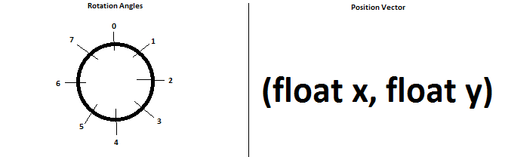

Rotation angles represent 45° turns from the starting angle of the robot (North). The position vector represents the offset, in feet, from the starting position of the robot (origin).